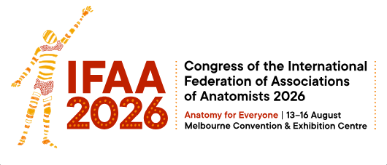

Travel Fellowship
IFAA 2026 Congress

We are pleased to offer another 10 travel awards, valued at $500 each, to support any ANZACA members and postgraduate students who have not already registered, to attend IFAA 2026. The travel fellowship can be used to help cover travel expenses, accommodation costs, and/or the Congress registration fee. No reimbursement will be provided for items such as food or beverages.
Eligibility Criteria
To be eligible, the applicant of the travel fellowship must:
- Be a current ANZACA member or a higher degree research student/candidate, enrolled in a postgraduate course (e.g., PhD, Masters, Honours), currently undertaking anatomical research at an institute or university.
- Deliver an accepted presentation (oral or poster) as the primary or presenting author.
- Hold current financial standard or student ANZACA membership.
- Full members must have been an ANZACA member for at least 12 months. In the case of student members, one of their supervisors needs to have been an ANZACA member for at least 12 months.
- Responsibility for the selection of recipients of the Travel Fellowships, the determination of the amount, and the condition of the award lies with the ANZACA Council members.
- The Travel Fellowship recipient must ensure that the ANZACA’s support is acknowledged in any presentation, report or publication. Wherever possible, the ANZACA logo should be included with the acknowledgement of ANZACA funding.
- The recipient is expected to submit a brief report or provide a photograph that can be published in an ANZACA newsletter and/or post about your IFAA2026 experience on one of ANZACA’s social media platforms (e.g., LinkedIn, Facebook).
To Apply
Complete the Application Form, which requests the following information:
- Personal details
– Details of funding requested
- Submitted abstract of your conference presentation
Submit your applicationApplication Form by Friday May 15th, 2026, 5pm AEDT.
Following notification of abstract acceptance from the IFAA2026 Congress Organisers, your application will be considered by the members of the ANZACA Council. You will subsequently be informed via email if your application was successful or not by early April.
To Claim Reimbursement
- Provide your bank account number and name, and email this with the relevant receipts to one of the ANZACA Treasurers (either erik.wibowo@sydney.edu.au (Australia) or natasha.flack@otago.ac.nz (New Zealand).
- After the Congress, you are required to send by email a brief report and/or provide a photograph that can be published in an ANZACA Newsletter, or post about your experience at IFAA2026 on social media (e.g., LinkedIn, facebook).

